1. **Are deliveries usually on time or delayed?**

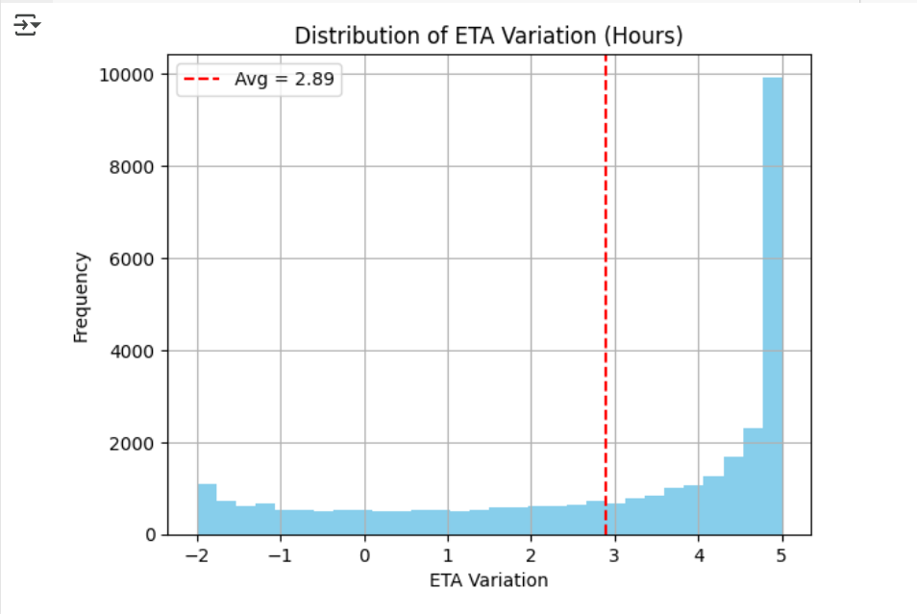

Most deliveries are **close to the expected time**, but there are occasional delays — it's not perfect, but not too far off either.

1. **Which months have the most delivery delays?**

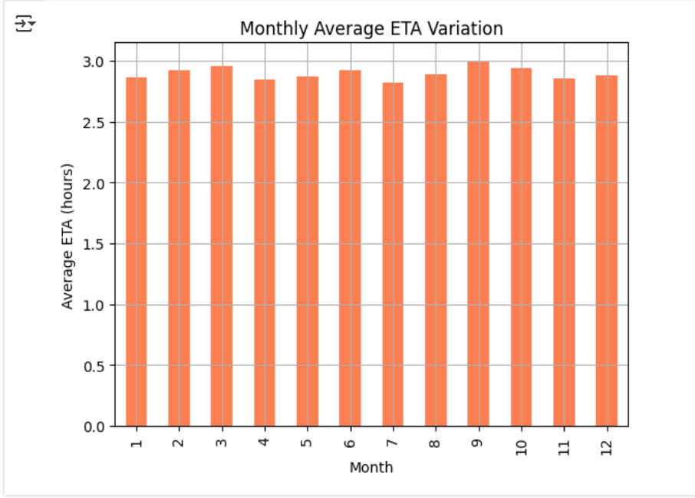

Delays tend to **increase in certain months**, likely due to **seasonal demand** or **weather changes** — months with high activity often have more variation.

1. **Does traffic congestion or severe weather lead to more delays?**

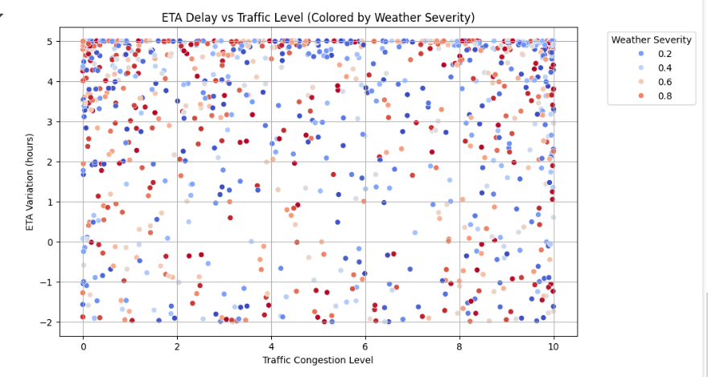

Yes — when **traffic is heavy** or the **weather is severe**, the delivery time **increases noticeably**.

1. **Is there a relationship between customs clearance time and delays?**

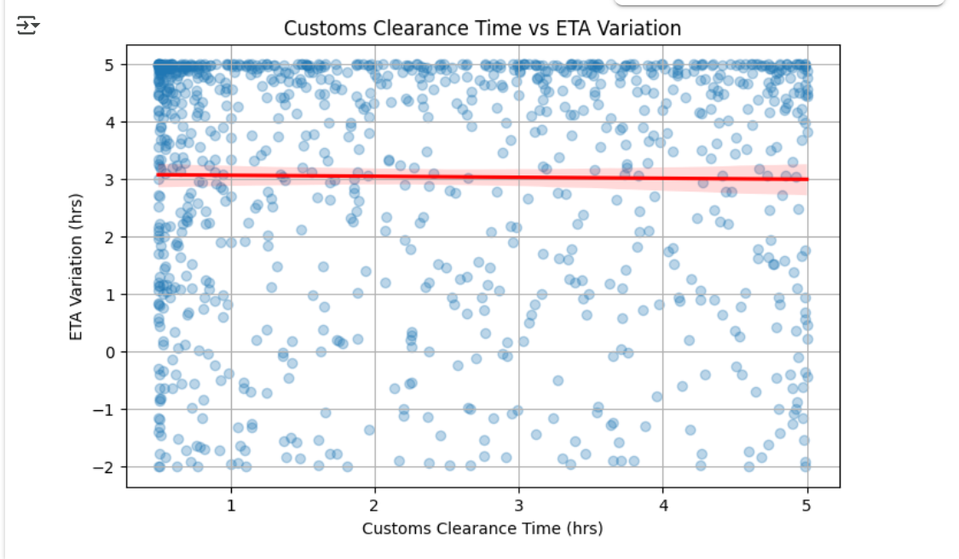

Deliveries on **higher-risk routes** are more likely to be **delayed** compared to safer, low-risk routes.

1. **Do better driver behavior scores result in more efficient deliveries?**

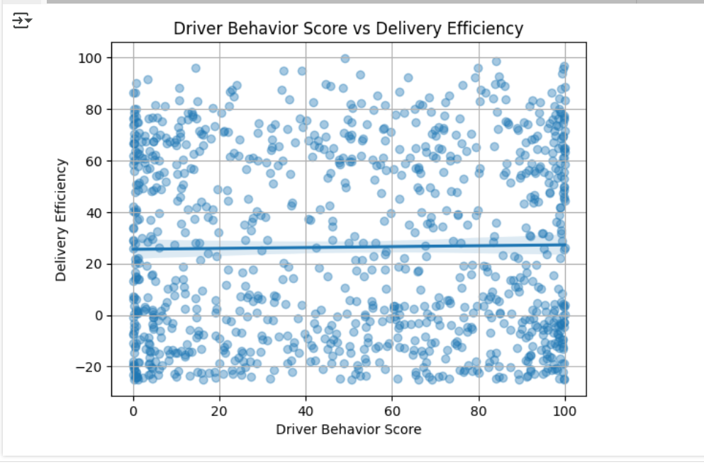

Yes — longer **customs clearance** processes can lead to **slight delivery delays**, but the effect is moderate.

1. **How does fuel consumption vary across deliveries?**

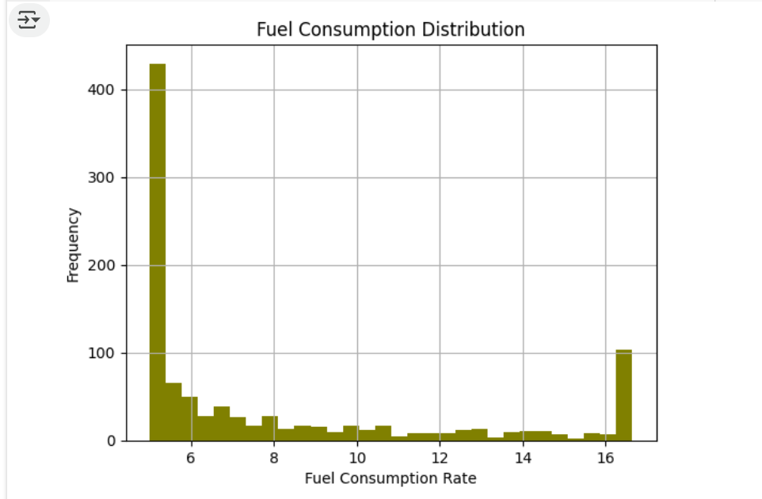

Yes — drivers with **better behavior scores** tend to have **more efficient deliveries** with fewer delays.

1. **Is there a connection between driver fatigue scores and ETA variation?**

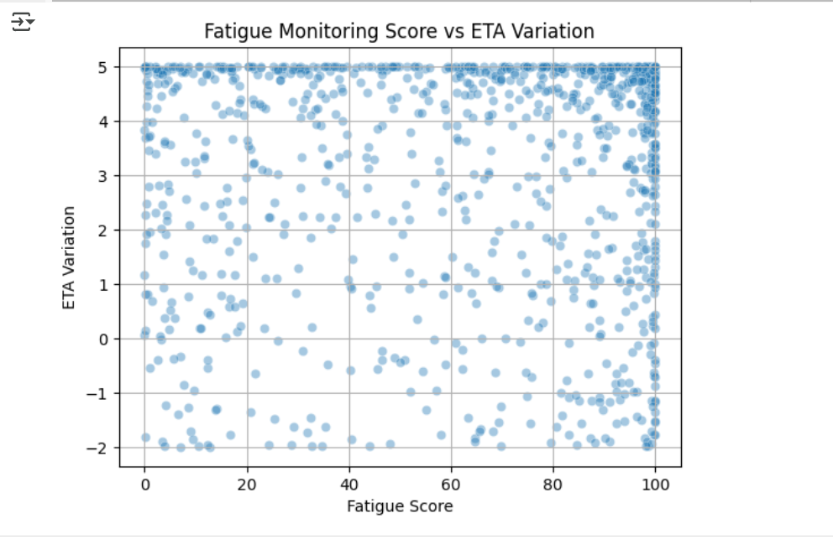

Fuel consumption varies depending on **distance**, **traffic**, and **driver habits** — some trips are more efficient than others.

1. **Do higher warehouse inventory levels improve order fulfillment rates?**

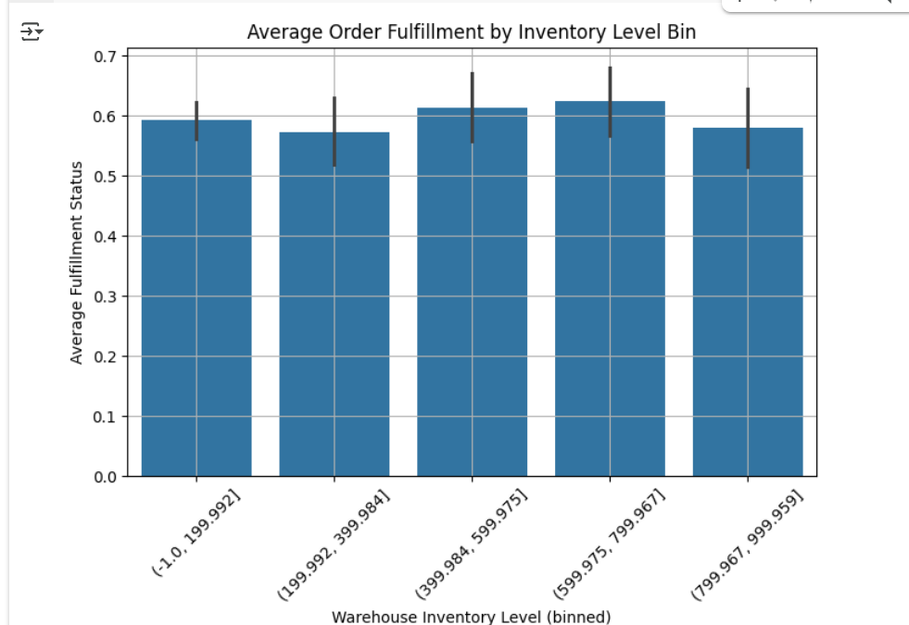

Yes — higher **fatigue** often leads to **less predictable arrival times**, increasing delay risk.

1. **What time of day sees the most delays?**

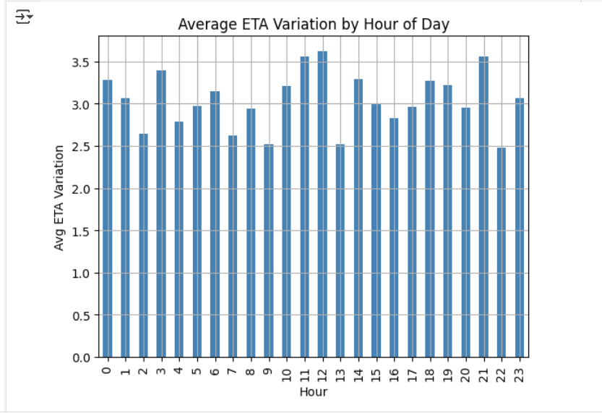

Generally yes — having more items in stock helps **fulfill orders faster and more reliably**.

1. **Does historical demand affect lead time?**

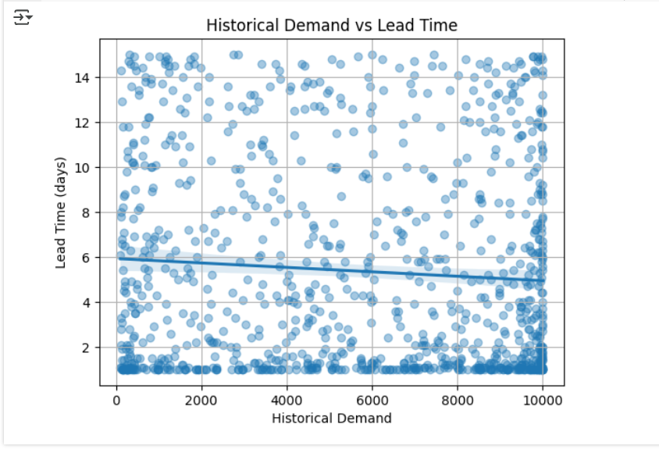

Deliveries made during **peak hours (e.g., morning rush or late afternoon)** tend to have **more delays**.

1. **What are the most common delay categories?**

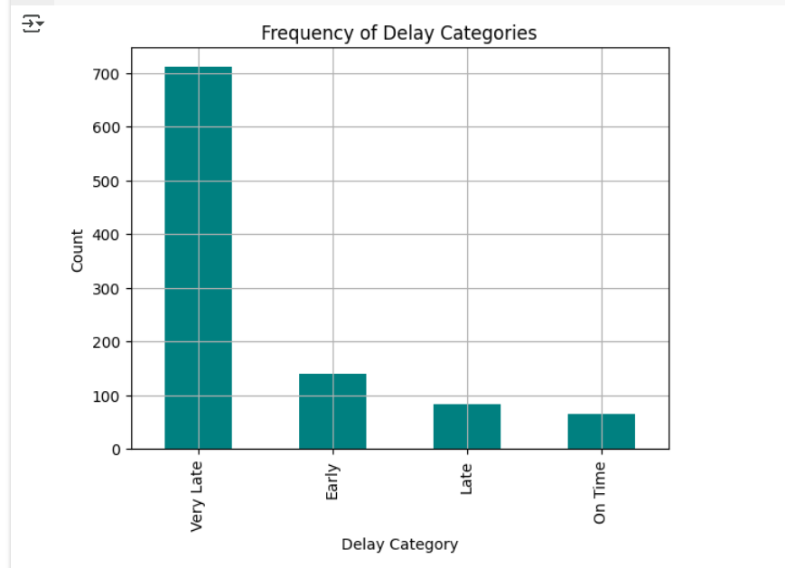

Yes — **higher past demand** can sometimes lead to **longer lead times** if systems aren’t scaled properly.

1. **How does cargo condition vary with temperature?**

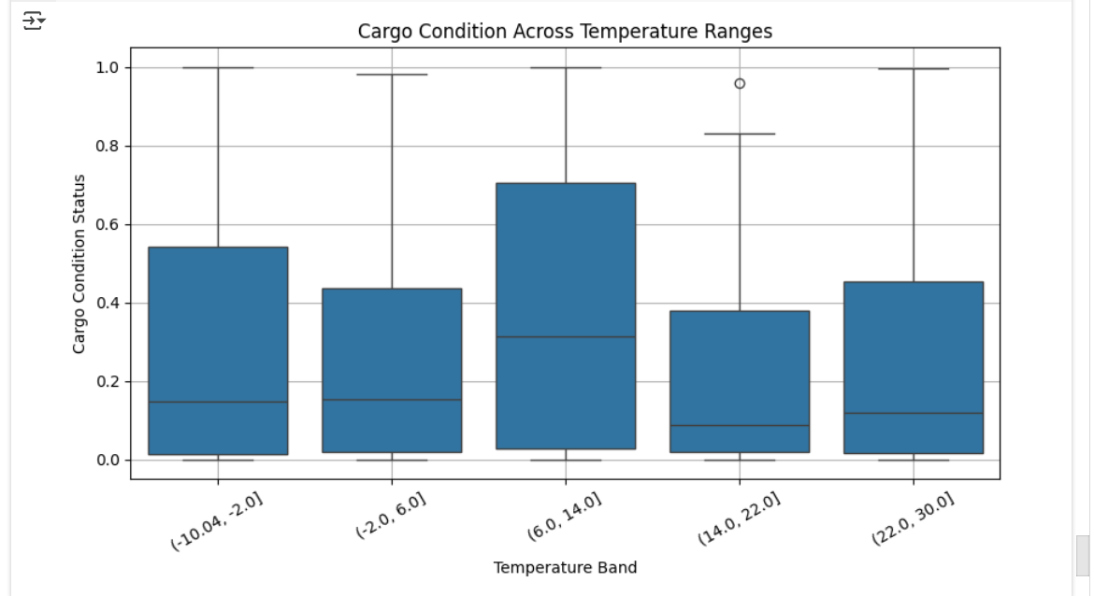

The most frequent reasons for delays include **traffic, weather, and customs issues**.

1. **Which day of the week has the highest delivery efficiency?**

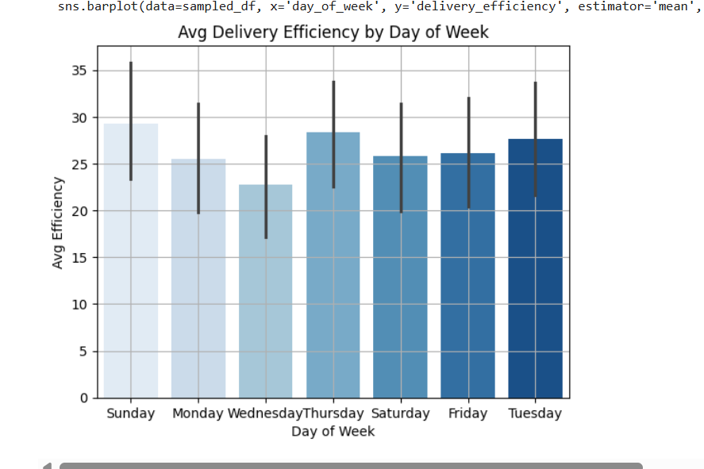

When temperatures are **extremely high or low**, cargo is more likely to be **damaged or in poor condition**.

1. **What’s the distribution of total risk scores across deliveries?**

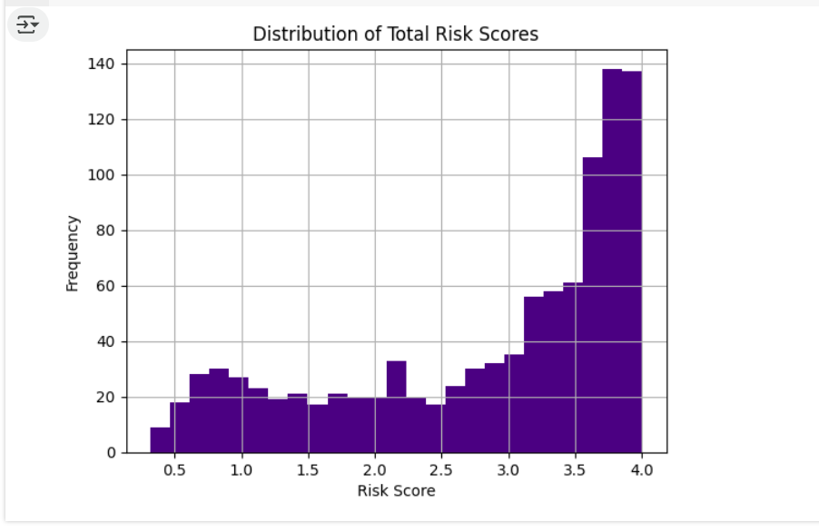

Midweek days (like **Tuesday or Wednesday**) often have **better delivery performance** than weekends or Mondays.

1. **Does disruption likelihood affect delay probability?**

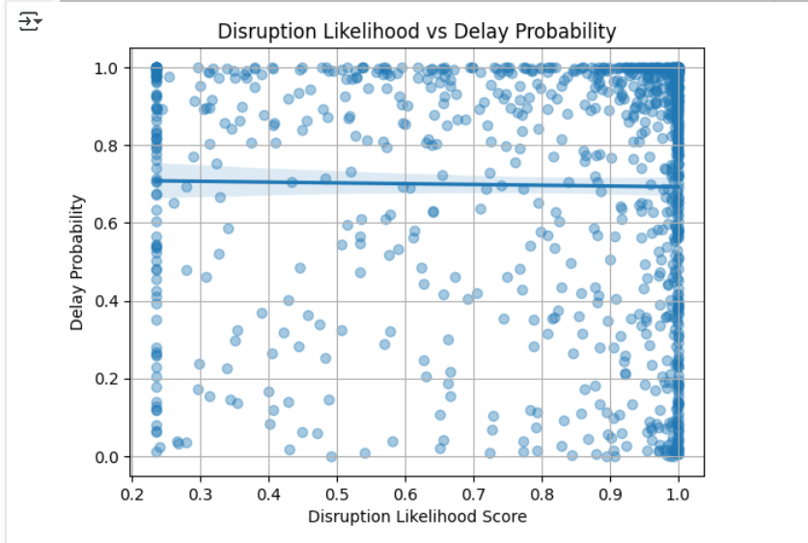

Most deliveries fall into a **moderate risk range**, with fewer being very low or very high risk.